**Monthly Report Cycle 1 01/03/22**

Team 142

Project Manager: Sergio Rodriguez Chavez

Project Management measures in place:

* Discord group created will all the team members to have an official place to run daily communications, address potential problems and discuss ideas for the project
* Kanban board to track the progress of each deliverable
* Bi-weekly team meetings held each Monday and Thursday
  + Assign weekly responsibilities
  + Collaborate on brainstorming of ideas
  + Split up into separate teams to tackle different deliverables at the same time and then provide feedback with results
  + Meeting minutes taken each meeting
* Weekly sponsor meeting
  + Update the sponsor on the weekly activities and inform on how the project is developing
* Individual team members giving feedback to the project manager on the rest of their team members contribution for that week
* GitHub repository set up for the project to upload all official documents where the whole team has access to them
  + Weekly meeting minutes
  + Final drafts of reports
  + Deliverables
    - Code used to create website
    - UML notation
    - User interface diagrams

Progress:

The tasks for the first month were all completed on time without any big setbacks occurring. Most of the tasks included setting up the team communication channels, setting up bi-weekly meetings, and informing everyone on the project details and what to expect. Project Initiation Report was created collaboratively and set up the team to start to begin with the development stage ahead of time. As shown in the screenshot below the sprint board for the development stage is underway and the deliverables are currently being worked on.

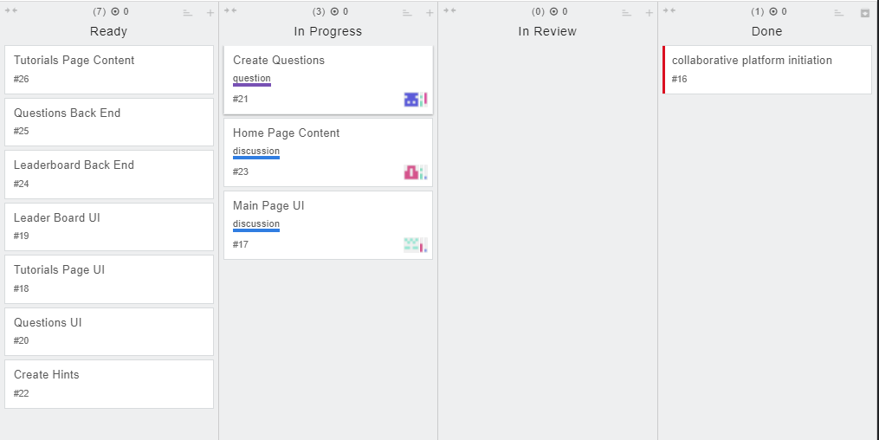

There are some deliverables that have been assigned to specific team members, so everyone is able to contribute evenly. There have been some issues that have arisen when starting the development stage that has forced some deliverables to still be in progress instead of being finished. These issues have been highlighted on the follow-up register below as well as other issues including team communication and team members not completing tasks. All the issues have been addressed and are no longer causing delays to the project.

